Chart Management Functional Requirements

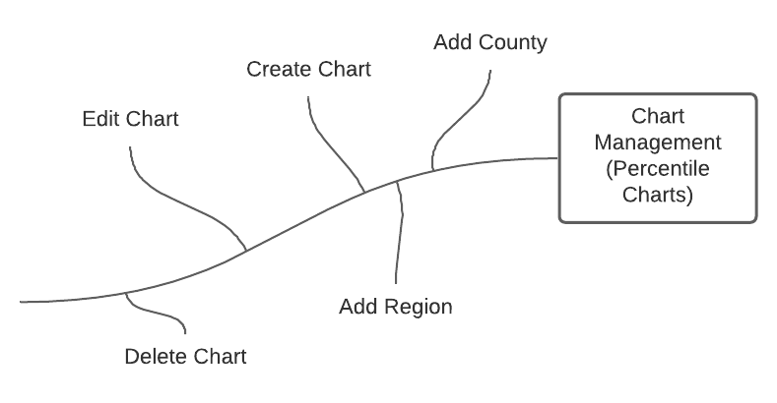

# Functional Requirements

1. The system shall allow the Admins and Cartographers to create new charts.
2. The system shall allow chart creators to edit any chart that they have created.
3. The system shall allow the Admins to edit everyone’s charts.
4. The chart management system will allow ***Chart Creators*** to only add one region.
5. The chart management system will not allow ***Chart Creators*** to add counties and regions simultaneously.
   1. ***Chart Creators*** must choose to add a county or a region, not both.
6. The chart management system will allow ***Chart Creators*** to select a specific CSV year.
7. The chart management system will allow ***Chart Creators*** to select a specific health indicator form the selected CSV year.
   1. All the health indicators are loaded dynamically from each CSV after the year is chosen.
8. The CPH system will allow ***Chart Creators*** to delete a chart.
9. The chart system shall handle undefined counties in specific CSV years that are defined in user created regions by
   1. Handling the null values, and
   2. Prompting the ***Chart Creators***, telling them the null county is undefined in the selected CSV year.